Zoom – How to Join a Meeting

Before joining a Zoom meeting on a computer or mobile device, you can download the Zoom app from https://zoom.us/ or the apple store. Otherwise, you will be prompted to download and install Zoom when you click a join link.
Prerequisites
- Each meeting has a unique 11-digit number called a MEETING ID that will be required to join a Zoom meeting (SIV AGM Meeting ID: 83168823593)
- A passcode has also been provided (Final Notice)

- Alternatively you can click the following link and the setup will begin automatically (we suggest you do this more than a few minutes prior to the AGM): https://us02web.zoom.us/j/83168823593?

- If you are joining via telephone, you will need the teleconferencing number.

For Windows/MAC
- Open the Zoom desktop client
- Join a meeting by clicking JOIN A MEETING.

- Enter the Meeting ID number SIV AGM Meeting ID: 83168823593, and display your name.
- Select if you would like to connect audio and/or video and click JOIN.
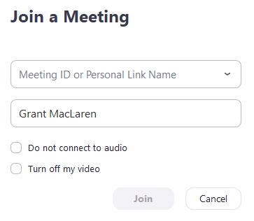

For IOS (through Zoom Mobile App)
- Open the Zoom mobile app. Download from the App store.
- Join a meeting
- Tap Join a Meeting

- Enter the Meeting ID number SIV AGM Meeting ID: 83168823593, and your display name.
- Select if you would like to connect audio and/or video and select Join.

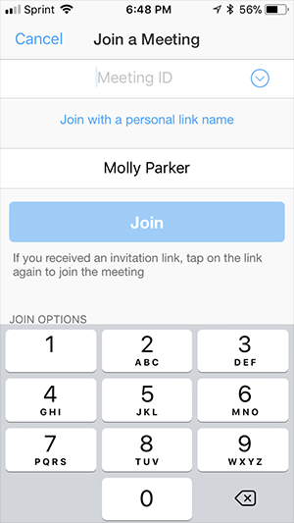

Zoom Etiquette – Attendee

Think of a Zoom Meeting as a face-to-face meeting and conduct yourself as you would if you were all present in the same room. In addition, there are some additional useful tips below to observe to help ensure the meeting goes smoothly for all involved:
- Join early – up to 5 minutes before the meeting start time
- If you haven’t used Zoom before click the link to download Zoom prior to the day of the meeting and familiarise yourself with any features you may need to use on the day – mute/unmute microphone, stop/start video, screenshare etc.
- Have your video on unless you are experiencing connection issues
- Find a quiet space without interruptions / background noise
- Have a plain background – avoid backlight from bright windows
- Have good lighting on your face so you can be seen clearly
- Adjust your camera to be at around eye level if possible – especially take note of the angle of your laptop screen if using the built-in camera.
- Mute your microphone when not talking
- Try to avoid talking over / at the same time as other participants
- Be aware you are on camera and try to avoid doing other tasks, checking emails, looking at your phone etc.

“The Annual General Meeting will be recorded for record-keeping."

